REVIEW/RESEARCH ARTICLE/SHORT COMMUNICATION
Instructions for the preparation of manuscript for NVEO; the title should accurately, clearly, and concisely reflect the emphasis and content of the work (18-pt)
 First Author^{1,*}, Second Author² and Third Author³ (12-pt)
¹Department is first, then University or Company name, Insert a complete correspondence (mailing) address, Abbreviate US states, Include city and COUNTRY (10-pt)
²Department of Pharmacognosy, Faculty of Pharmacy, Anadolu University, 26470, Eskişehir, TURKEY
*Corresponding author. Email: editorial@nveo.com
Submitted: 01.01.2020; Accepted: 01.01.2020
Abstract (9-pt)
Manuscripts should be accompanied by an abstract. The abstract should be clear, descriptive, self-explanatory and between 100 to 250 words. The abstract should briefly state the problem or purpose of the research, indicate the theoretical or experimental plan used, summarize the principal findings, and point out the major conclusions. Do not include references or formulae in the abstract.
Keywords: Keyword one, keyword two, keyword three, keyword four, keyword five
Introduction (14-pt)
Prepare your paper in the same style as used in this sample document. The font type for running text (body text) is 11-point Calibri, paragraphs after 6-nk space. Use 1,15-line spacing throughout the document. Manuscripts should be compiled in the following order: Title; Abstract; Keywords; Introduction, Materials and Methods, Results and Discussion, Conclusion (if necessary), Acknowledgments; Appendixes (if necessary); Supplemental documents (if necessary), References.
Manuscripts must be written in English. Authors whose native language is not English are recommended to seek the advice of a native English speaker, if possible, before submitting their manuscripts. The pages in the manuscript should not be numbered and in the text no reference should be made to page numbers; if necessary, one may refer to sections. Try to avoid excessive use of italics and bold face. These instructions also contain the necessary information for APA reference style editing. The font type for REFERENCES running text is 10-point Calibri.
Materials and Methods (14-pt)
Heading two (12-pt)
Text (Body text should be regular form and 11-pt)
Heading three (italic form 11-pt)
Text (Body text should be regular form and 11-pt)
Results and Discussion (14-pt)
Results and discussion text (Body text should be regular form and 11-pt)
Heading two (optional) (12-pt)
Results and discussion text (Body text should be regular form and 11-pt)
Tables: The number of the tables should be indicated as Table 1., Table 2. etc, and refer to all of them in the text. Number all tables with arabic numerals sequentially. Column headings should be brief, but sufficiently explanatory. Maximum table width of 16.8 cm. The minimum font size for characters in tables is 9 points. SI units should be used.
Table 1. Each table should have a brief and self-explanatory title (10-pt)
Heading 1 (10-pt) | Heading 2 | Heading 3
Textª (9-pt) | Text | Text
Text^{b} | Text | Text
ªAny explanations essential to the understanding of the table should be given in footnotes at the bottom of the table. To indicate specific notes, use superscript lowercase letters (e.g. ª, ^{b}, ^{c}), and order the superscripts from left to right, top to bottom. ^{b}Each table’s first footnote must be the superscript.
Figures and Schemes: It is possible to have figures printed in colour. Do not use illustrations taken from the Internet. Figures should be sized a minimum resolution of 600 dpi. Scheme or figure with a wide of 16.8 cm (max)
Figure 1. Description... (10-pt)
Any explanations should be given in footnotes at the bottom of the scheme or figure. (9-pt)
Conclusion (optional) (14-pt)
ACKNOWLEDGMENT (10-pt)
Generally, the last paragraph of the paper is the place to acknowledge people (dedications), places, and financing (you may state grant numbers and sponsors here).
CONFLICTS OF INTEREST
The authors have no conflicts of interest to declare.
REFERENCES (14-pt)
Calfee, R. C., & Valencia, R. R. (1991). APA guide to preparing manuscripts for journal publication. Washington, DC: American Psychological Association. (10-pt)
Harlow, H. F. (1983). Fundamentals for preparing psychology journal articles. Journal of Comparative and Physiological Psychology, 55, 893-896.
Moller, G. (2002, August). Ripples versus rumbles [Letter to the editor]. Scientific American, 287(2), 12.
O'Neil, J. M., & Egan, J. (1992). Men's and women's gender role journeys: A metaphor for healing, transition, and transformation. In B. R. Wainrib (Ed.), Gender issues across the life cycle (pp. 107-123). New York, NY: Springer.
Plath, S. (2000). The unabridged journals. K. V. Kukil (Ed.). New York, NY: Anchor.
Scruton, R. (1996). The eclipse of listening. The New Criterion, 15(3), 5-13.

APA Format Citation Guide

This is a complete guide to APA (American Psychological Association) in-text and reference list citations.

Core Components of an APA Reference:
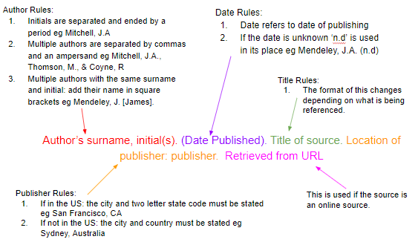

1. APA Referencing Basics: Reference List
A reference list is a complete list of references used in a piece of writing including the author name, date of publication, title and more. An APA reference list must:
- Be on a new page at the end of the document
- Be centred
- Be alphabetically by name of first author (or title if the author isn’t known, in this case a, an and the should be ignored)
  - If there are multiple works by the same author these are ordered by date, if the works are in the same year they are ordered alphabetically by the title and are allocated a letter (a,b,c etc) after the date
- Contain full references for all in-text references used

2. APA Referencing Basics: In-Text Citation
In-text references must be included following the use of a quote or paraphrase taken from another piece of work.
In-text citations are citations within the main body of the text and refer to a direct quote or paraphrase. They correspond to a reference in the main reference list. These citations include the surname of the author and date of publication only. Using an example author James Mitchell, this takes the form:
Mitchell (2017) states… Or …(Mitchell, 2017).
The structure of this changes depending on whether a direct quote or parenthetical used:
- Direct Quote: The citation must follow the quote directly and contain a page number after the date, for example (Mitchell, 2017, p.104). This rule holds for all of the variations listed.
- Parenthetical: The page number is not needed.

Two Authors:
The surname of both authors is stated with either ‘and’ or an ampersand between. For example:
Mitchell and Smith (2017) state… Or …(Mitchell & Smith, 2017).

Three, Four or Five Authors:
For the first cite, all names should be listed:
Mitchell, Smith, and Thomson (2017) state… Or …(Mitchell, Smith, & Thomson, 2017).
Further cites can be shorted to the first author’s name followed by et al:
Mitchell et al (2017) state… Or …(Mitchell et al, 2017).

Six or More Authors:
Only the first author’s surname should be stated followed by et al, see the above example.

No Authors:
If the author is unknown, the first few words of the reference should be used. This is usually the title of the source.
If this is the title of a book, periodical, brochure or report, is should be italicised. For example:
(A guide to citation, 2017).
If this is the title of an article, chapter or web page, it should be in quotation marks. For example:
(“APA Citation”, 2017).

Citing Authors With Multiple Works From One Year:
Works should be cited with a, b, c etc following the date. These letters are assigned within the reference list, which is sorted alphabetically by the surname of the first author. For example:
(Mitchell, 2017a) Or (Mitchell, 2017b).

Citing Multiple Works in One Parentheses:
If these works are by the same author, the surname is stated once followed by the dates in order chronologically. For instance:
Mitchell (2007, 2013, 2017) Or (Mitchell, 2007, 2013, 2017)
If these works are by multiple authors then the references are ordered alphabetically by the first author separated by a semicolon as follows:
(Mitchell & Smith 2017; Thomson, Coyne, & Davis, 2015).

Citing a Group or Organisation:
For the first cite, the full name of the group must be used. Subsequently this can be shortened. For example:
First cite: (International Citation Association, 2015)
Further Cites: (Citation Association, 2015)

3. How to Cite Different Source Types
- In-text citation doesn’t vary depending on source type, unless the author is unknown.
- Reference list citations are highly variable depending on the source.

How to Cite a Book (Title, not chapter) in APA Format
Book referencing is the most basic style; it matches the template above, minus the URL section. So the basic format of a book reference is as follows:
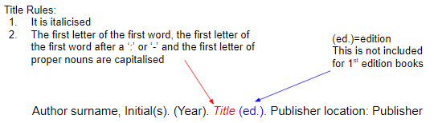

Book referencing examples:

Mitchell, J.A., Thomson, M., & Coyne, R.P. (2017). A guide to citation. London, England: My Publisher
Jones, A.F & Wang, L. (2011). Spectacular creatures: The Amazon rainforest (2nd ed.). San Jose, Costa Rica: My Publisher

How to Cite an Edited Book in APA Format
This reference format is very similar to the book format apart from one extra inclusion: (Ed(s)). The basic format is as follows:
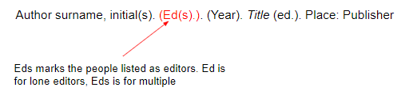

Edited book example:
Williams, S.T. (Ed.). (2015). Referencing: A guide to citation rules (3rd ed.). New York, NY: My Publisher

How to Cite a Chapter in an Edited Book in APA Format
Edited books are collations of chapters written by different authors. To reference a single chapter, a different format is needed. The basic structure is as follows:
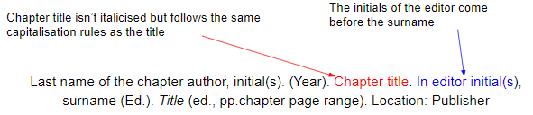

Edited book chapter example:
In the following example, B.N. Troy is the author of the chapter and S.T. Williams is the editor.
Troy, B.N. (2015). APA citation rules. In S.T, Williams (Ed.). A guide to citation rules (2nd ed., pp. 50-95). New York, NY: Publishers.

How to Cite an E-Book in APA Format
An E-Book reference is the same as a book reference expect the publisher is swapped for a URL. The basic structure is as follows:
Author surname, initial(s) (Ed(s).*). (Year). Title (ed.*). Retrieved from URL
*optional.

E-Book example:
Mitchell, J.A., Thomson, M., & Coyne, R.P. (2017). A guide to citation. Retrieved from https://www.mendeley.com/reference-management/reference-manager

How to Cite an E-Book Chapter in APA Format
This follows the same structure as an edited book chapter reference except the publisher is exchanged for a URL. The structure is as follows:
Last name of the chapter author, initial(s). (Year). Chapter title. In editor initial(s), surname (Ed.). Title (ed., pp.chapter page range). Retrieved from URL

E-Book chapter example:
Troy, B.N. (2015). APA citation rules. In S.T, Williams (Ed.). A guide to citation rules (2nd ed., pp. 50-95). Retrieved from https://www.mendeley.com/reference-management/reference-manager

How to Cite a Journal Article in Print or Online in APA Format
Articles differ from book citations in that the publisher and publisher location are not included. For journal articles, these are replaced with the journal title, volume number, issue number and page number. The basic structure is:
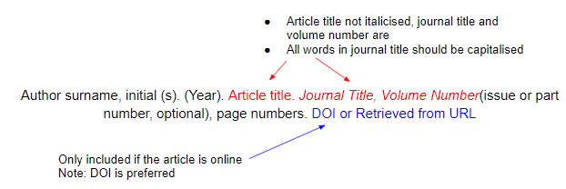

Journal Article Example:
Mitchell, J.A. (2017). Citation: Why is it so important. Mendeley Journal, 67(2), 81-95.

How to Cite Magazine Articles in Print or Online in APA Format
The basic structure is as follows:
Author surname, initial(s). (Year, month day). Title. Title of the Magazine, pp.

Magazine Article Example:
Mitchell, J.A. (2017). How citation changed the research world. The Mendeley, pp. 26-28

How to Cite an Image in APA Format
The basic format to cite an image is:
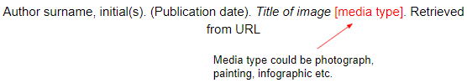

Image Example:
Millais, J.E. (1851-1852). Ophelia [painting]. Retrieved from www.tate.org.uk/art/artworks/millais-ophelia-n01506

How to Cite a Website in APA Format
When citing a website, the basic structure is as follows:
Author surname, initial(s). (Year, month day). Title. Retrieved from URL

Website example:
Mitchell, J.A. (2017, May 21). How and when to reference. Retrieved from https://www.howandwhentoreference.com.
To learn more about citing a web page and entire websites in APA, MLA or Harvard check out How to Cite a Website post.
For a summary of all the references for each source type along with examples take a look at our Ultimate Citation Cheat Sheet. It also contains examples for MLA 8 and Harvard formats.

